Polymorphism

1. What does polymorphism mean?
   1. changing shape
   2. have many shapes
   3. be immutable
   4. Easy
2. Is polymorphism a feature of object-oriented programming?
   1. TRUE
   2. False
3. Which of the following best describes polymorphism?
   1. It is the ability for a message/data to be processed in more than one way.
   2. It is the ability for a message/data to be processed in a single form
   3. It is the ability for many messages/data to be processed in one way.
   4. It is the ability for undefined messages/data to be processed in at least one way.
4. When is method overloading determined?
   1. At runtime
   2. At the time of encoding
   3. At compile time
   4. At runtime
5. Polymorphism consists of getting an object of a class to behave like an object of any of its subclasses. It can be applied to both methods and data types.
   1. TRUE
   2. False
6. An overridden method in a derived class must follow the following rules:
   1. It must have the same name.
   2. It must have the same type and number of parameters.
   3. The access level type must be equal to or more accessible.
   4. The return value must be of the same type or a subtype.
7. In the following UML diagram: The object-oriented programming pillar (Polymorphism ) is represented ?

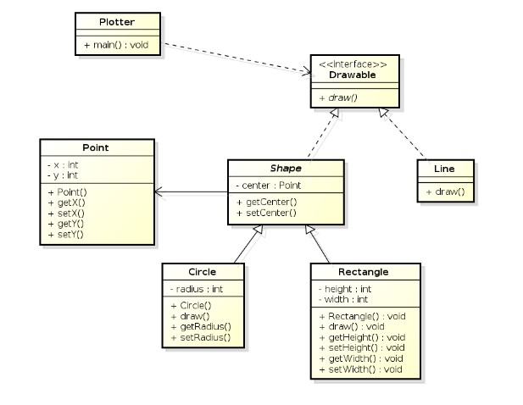

* 1. TRUE
  2. False

1. The following UML diagram: Represents the 4 pillars of object-oriented programming (Abstraction - Encapsulation - Polymorphism - Inheritance )?

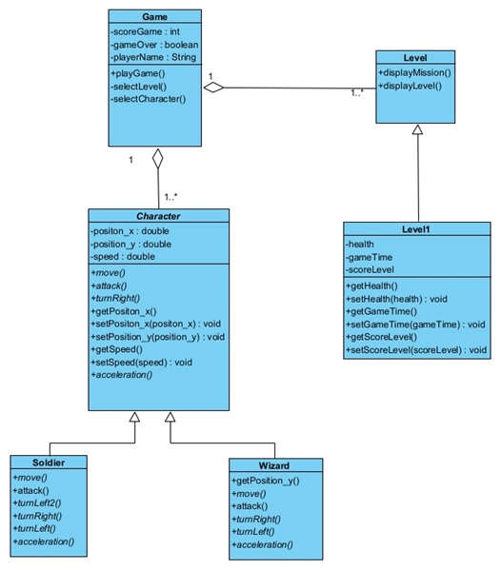

* 1. TRUE
  2. False

1. What does the name polymorphism translate to?
   1. many shapes
   2. Many changes
   3. two ways
   4. shapes liquid
2. An object that has more than one shape is called...
   1. Inheritance
   2. Abstraction
   3. Interface
   4. Polymorphism